Sunant, solar total intensity at 11.2 GHz (cases #1 - #24) and radio maps at 8 mm on the day when CME appeared

Totally four days period, starting at two days before CME appeared and finishing one day after CME appeared

**Case #1: CME from AR11166**

**Case #2: CME from AR11169**

**Case #3: CME from AR11190**

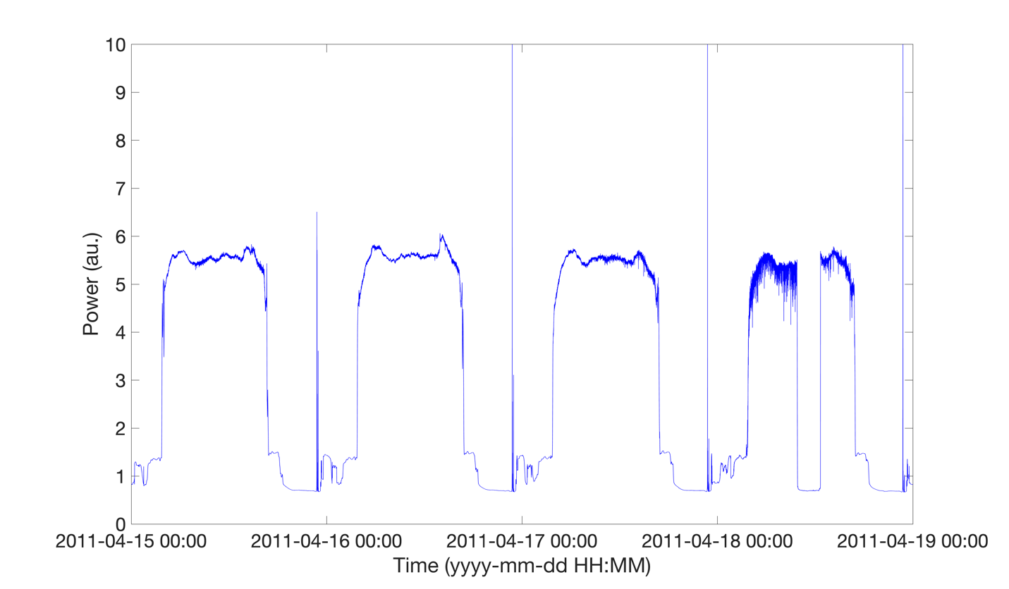

**Case #4: CME from AR11226**

**Case #5: CME from AR11226**

**Case #6: CME from AR11226**

**Case #7: CME from AR11247**

**Case #8: CME from AR11261**

**Case #9: CME from AR11261**

**Case #10: CME from AR11261**

**Case #11: CME from AR11263 (AR marked in map)**

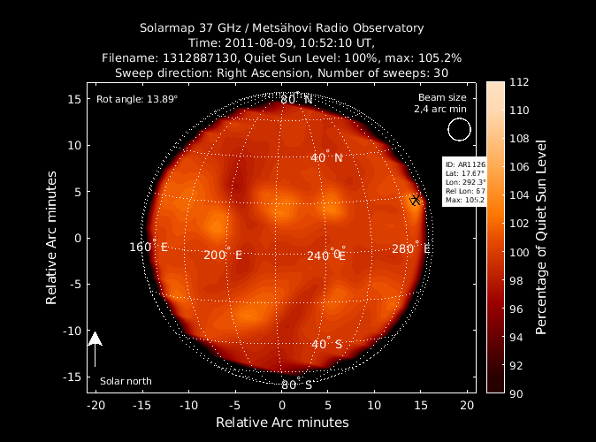

**Case #12: CME from AR11476**

**Case #13: CME from AR11476**

**Case #14: CME from AR11504 (AR11504 is very close to AR11505, on radio map the connected to one large RB)**

**Case #15: CME from AR11719**

**Case #16: CME from AR11731**

**Case #17: CME from AR11748**

**Case #18: CME from AR11762**

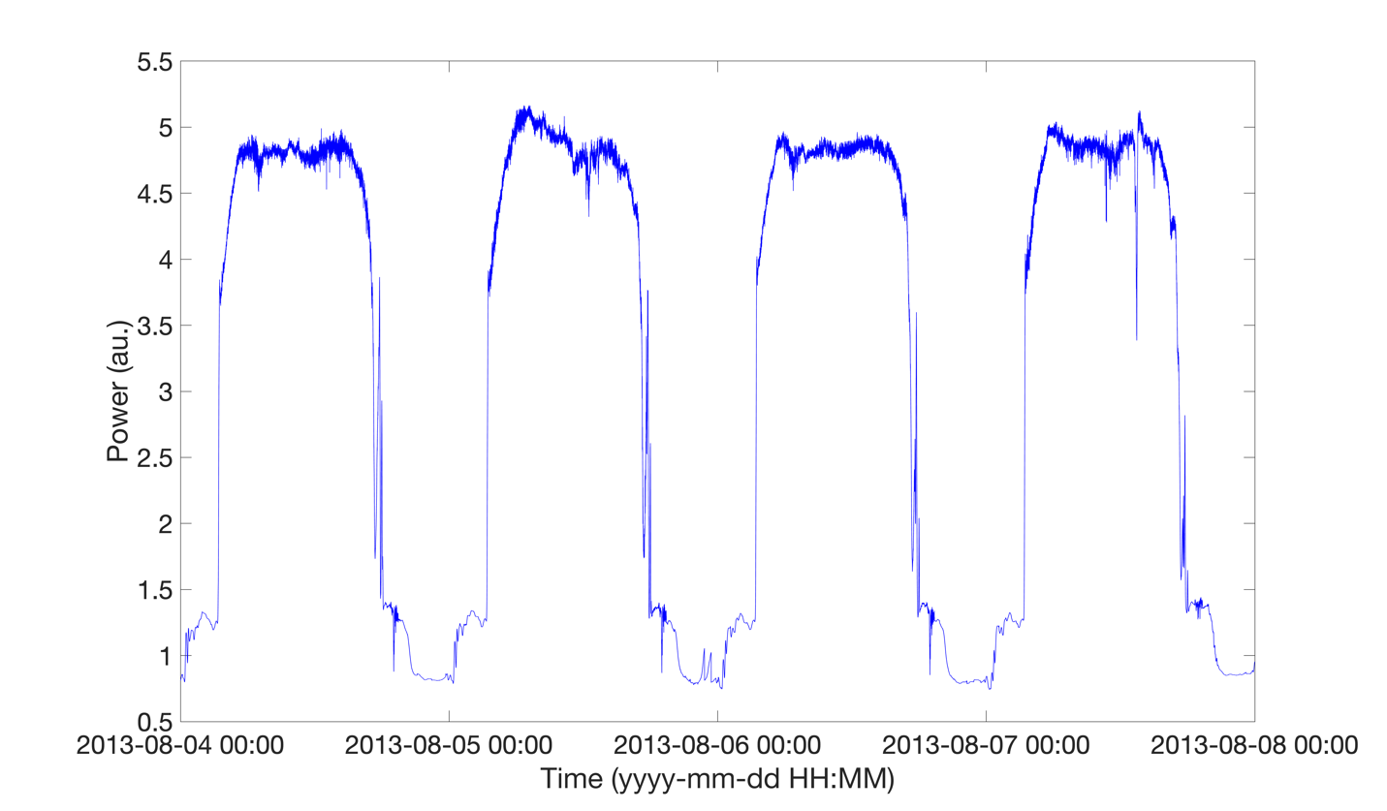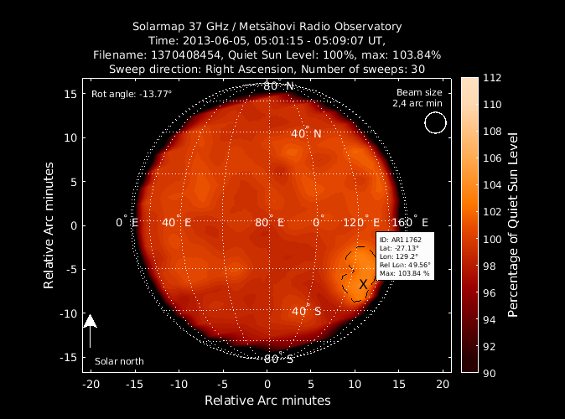

**Case #19: CME from AR11809**

**Case #20: AR11818**

**Case #21: CME from AR12152**

**Case #22: CME from AR12565 (the most intense RB on the map)**

**Case #23: CME from AR12655 (the second highest intense RB on the map)**

**Case #24: CME from AR12673 (the most intense RB on the map)**

